5

Syed Muhammad Akbar (237544)

msyed.bscs17seecs

Abstract

Login

AdvanceD programming LAB 12

REACT NATIVE

BSCS 7B

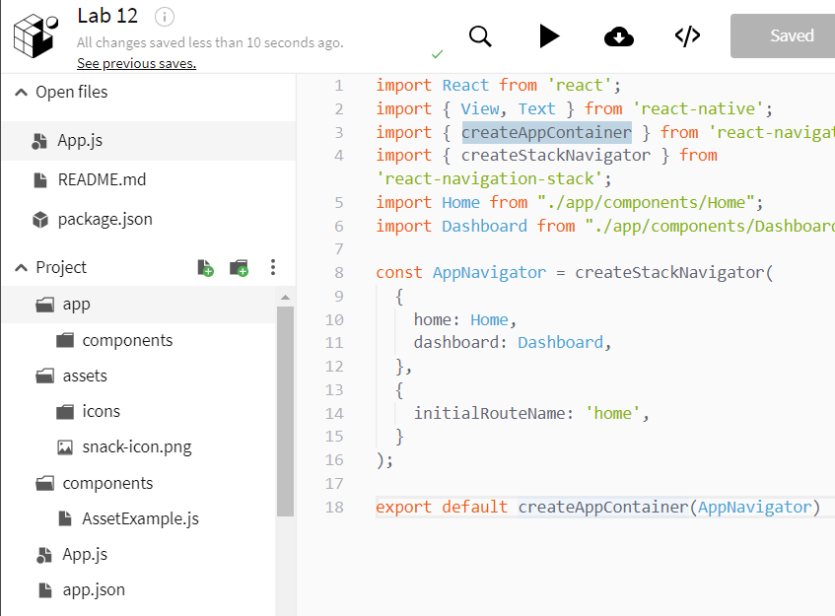

|  |
| --- |
| App.js |
| import React from 'react';  import { View, Text } from 'react-native';  import { createAppContainer } from 'react-navigation';  import { createStackNavigator } from 'react-navigation-stack';  import Home from "./app/components/Home";  import Dashboard from "./app/components/Dashboard"    const AppNavigator = createStackNavigator(  {  home: Home,  dashboard: Dashboard,  },  {  initialRouteName: 'home',  }  );    export default createAppContainer(AppNavigator) |
|  |

|  |
| --- |
| AssetExample.js |

import * as React from 'react';

import { Text, View, StyleSheet, Image } from 'react-native';

export default class AssetExample extends React.Component {

render() {

return (

<View style={styles.container}>

<Text style={styles.paragraph}>

Local files and assets can be imported by dragging and dropping them into the editor

</Text>

<Image style={styles.logo} source={require('../assets/snack-icon.png')} />

</View>

);

}

}

const styles = StyleSheet.create({

container: {

alignItems: 'center',

justifyContent: 'center',

padding: 24,

},

paragraph: {

margin: 24,

marginTop: 0,

fontSize: 14,

fontWeight: 'bold',

textAlign: 'center',

},

logo: {

height: 128,

width: 128,

}

});

|  |
| --- |
| App/component/dashboard |

import React from 'react';

import { View, Text } from 'react-native';

class Dashboard extends React.Component {

render() {

return (

<View style={{ flex: 1, alignItems: 'center', justifyContent: 'center' }}>

<Text>Welcome by Syed Muhammad Akbar</Text>

</View>

);

}

}

export default Dashboard;

|  |
| --- |
| App/component/Home |

import React from 'react';

import { View, Text, TextInput, Button } from 'react-native';

class HomeScreen extends React.Component {

state = {

username: "",

password: ""

}

static navigationOptions = {

title: "Whazzaap"

}

checkLogin() {

const {username, password} = this.state;

console.log(username + " " + password);

fetch("http:10.7.70.145:5000/", {

method:"post",

headers: {"Conetent-Type": "application/json"},

body: JSON.stringify({

"name": username,

"password": password

})

})

.then(res => res.text())

.then(res => {

if(res == "Succ"){

this.props.navigation.navigate("dashboard");

}

else{

alert("Invalid username or password");

}

})

/*

if(username == "admin" && password == "admin"){

//alert("Login Success! Welcome Admin.");

this.props.navigation.navigate("dashboard");

}

else{

alert("Invalid username or password.");

}

*/

}

render() {

return (

<View style={{ flex: 1, alignItems: 'center', justifyContent: 'center' }}>

<Text style={{fontSize: 30}}>Login for the service!</Text>

<Text style={{fontSize: 30}}> </Text>

<Text style={{fontSize: 15}}>Username</Text>

<TextInput

style={{backgroundColor: "lightgrey", width: 350, textAlign: "center", fontSize: 15}}

onChangeText = {text => this.setState({username: text})}

/>

<Text style={{fontSize: 15}}> </Text>

<Text style={{fontSize: 15}}>Password</Text>

<TextInput

style={{backgroundColor: "lightgrey", width: 350, textAlign: "center", fontSize: 15}}

secureTextEntry = {true}

onChangeText = {text => this.setState({password: text})}

/>

<Text style={{fontSize: 15}}> </Text>

<Button title="Login" onPress={() => this.checkLogin()} />

</View>

);

}

}

export default HomeScreen;

